WD1 Age structure of turbot landings.

Which data are available, for which periods

There was no long-term continuous programme for age sampling of landings in any of the countries. Therefore, the age structure of the landings is estimated using data from different sources in different time periods (Figure 2.6.3). Starting in 1975, there is a four year time period for which the age structure of the landings have been estimated by Weber (1979). The age structure is estimated from market samples taken in Cuxhaven and Hamburg and research vessel surveys. Most of the samples represent landings in the eastern part of 4.b. The structure is based on a total of 9360 length and 6389 weight measurements combined with 6788 age samples. The total numbers-at-age in the overall landings were estimated in the original publication by combining the age samples with the quarterly landings for England, the Netherlands and Germany.

The second dataset spans the period 1981–1990, is derived from landings in the Netherlands and available in the “Datubras” project report (Boon and Delbare, 2000). A stratified sampling scheme was used to collect the samples, using quarters, auctions, and market categories as stratification levels. Between 398 and 862 age samples were taken annually for age-determination of fish. Most of the samples represent Areas 4b and 4c. The Dutch data are subsequently raised to the total international landings.

The third dataset spans the period 2000–2002. It was supplied by Cefas and based on the UK landings of turbot. These were raised on an annual basis to the total landings.

The fourth and final dataset stems again from the Netherlands. It spans the years 1998 and 2004–2016. The data comes almost entirely from the 80 mm beam trawl fishery. The age structure is estimated from stratified sampling accounting for auctions, quarters and market categories. These are raised to total Dutch landings by quarter. Between 494 and 1921 age samples were taken per year. The total Dutch landings are subsequently raised to the total international landings per year.

In preparation of the inter-benchmark, Danish age and length structure for landings was made available. The age structure was available for 2014-2016, and the length structure was available for 2002-2016. The age data was imported into intercatch and used to raise new age structure for landings in the period 2014-2016.

References

Boon, A.R., and Delbare, D. 2000. By-catch species in the North Sea flatfish fishery (data on turbot and brill) preliminary assessment DATUBRAS, study 97/078. Final RIVO report C020/00. 107 pp.

Weber, W. 1979. On the turbot stock in the North Sea. ICES C.M. 1979/G:12.

Tables

Table 1 Landings at age as used in WGNSSK 2017

age

year 1 2 3 4 5 6 7 8 9 10

1975 1.15 427.35 1012.35 239.35 108.35 124.55 90.35 47.25 42.05 146.550

1976 0.35 350.35 1346.35 392.35 114.35 76.25 57.75 50.55 38.55 174.150

1977 18.55 895.35 644.35 531.35 166.35 44.15 30.85 42.35 36.95 142.350

1978 0.35 1324.35 1273.35 309.35 268.35 76.35 37.95 29.35 20.75 65.050

1979 NA NA NA NA NA NA NA NA NA NA 1980 NA NA NA NA NA NA NA NA NA NA

1981 0.35 299.35 755.35 532.35 458.35 175.35 67.35 35.35 40.35 32.350

1982 0.35 169.35 1046.35 267.35 167.35 292.35 98.35 49.35 41.35 65.350

1983 0.35 402.35 673.35 479.35 110.35 113.35 180.35 91.35 31.35 81.350

1984 0.35 1296.35 1223.35 311.35 157.35 60.35 57.35 74.35 51.35 70.350

1985 0.35 795.35 2415.35 654.35 179.35 109.35 26.35 38.35 48.35 74.350

1986 0.35 371.35 1470.35 697.35 183.35 67.35 29.35 16.35 18.35 90.350

1987 13.35 648.35 546.35 676.35 158.35 52.35 19.35 5.35 5.35 60.350

1988 36.35 1084.35 897.35 178.35 176.35 90.35 28.35 42.35 10.35 25.350

1989 0.35 594.35 1037.35 315.35 139.35 73.35 28.35 22.35 10.35 29.350

1990 43.35 957.35 1032.35 305.35 160.35 73.35 98.35 58.35 13.35 39.350

1991 NA NA NA NA NA NA NA NA NA NA

1992 NA NA NA NA NA NA NA NA NA NA

1993 NA NA NA NA NA NA NA NA NA NA

1994 NA NA NA NA NA NA NA NA NA NA

1995 NA NA NA NA NA NA NA NA NA NA

1996 NA NA NA NA NA NA NA NA NA NA

1997 NA NA NA NA NA NA NA NA NA NA

1998 0.35 540.35 1158.35 476.35 97.35 39.65 11.65 10.45 1.26 8.350

1999 NA NA NA NA NA NA NA NA NA NA

2000 4.85 255.35 938.35 270.35 315.35 145.05 116.45 51.65 59.14 72.700

2001 0.35 478.35 1642.35 357.35 64.35 75.85 55.45 65.05 21.93 61.490

2002 468.35 1283.35 1237.35 265.35 123.35 32.45 16.75 17.65 3.62 9.870

2003 267.35 2429.35 586.35 378.35 90.35 42.25 26.65 9.35 8.02 9.430

2004 491.15 2234.35 894.35 156.35 93.35 11.25 8.85 4.45 1.37 1.730

2005 291.45 1678.35 611.35 195.35 21.35 18.85 2.55 12.15 1.38 3.420

2006 706.05 1312.35 644.35 95.35 28.35 6.65 13.25 3.45 1.05 10.660

2007 80.25 2829.35 627.35 290.35 41.35 29.95 8.75 9.85 0.35 6.340

2008 184.85 1404.35 854.35 229.35 203.35 49.35 13.75 1.55 7.16 2.620

2009 117.25 1076.35 1005.35 434.35 92.35 26.25 11.75 8.15 2.00 9.710

2010 237.15 1193.35 328.35 263.35 146.35 75.25 26.35 6.35 4.83 6.140

2011 219.45 2017.35 626.35 115.35 143.35 80.35 33.85 16.65 3.72 4.840

2012 0.35 1949.35 793.35 272.35 43.35 65.25 74.55 13.65 6.88 4.710

2013 161.68 1480.55 1013.13 304.82 85.22 24.34 39.35 16.95 2.76 4.540

2014 94.56 548.40 620.09 461.37 162.70 78.15 24.21 21.30 11.21 32.210

2015 57.39 1911.06 531.05 347.21 354.88 111.12 34.10 12.59 11.60 17.554

2016 0.35 1397.51 1337.85 378.18 406.16 185.09 18.50 31.56 3.31 16.340

Table 2 Landings at age with the inclusion of Danish data in 2014-2016

age

year 1 2 3 4 5 6 7 8 9 10

1975 1.15 427.35 1012.35 239.35 108.35 124.55 90.35 47.25 42.05 146.55

1976 0.00 350.35 1346.35 392.35 114.35 76.25 57.75 50.55 38.55 174.15 1977 18.55 895.35 644.35 531.35 166.35 44.15 30.85 42.35 36.95 142.35 1978 0.00 1324.35 1273.35 309.35 268.35 76.35 37.95 29.35 20.75 65.05 1979 NA NA NA NA NA NA NA NA NA NA

1980 NA NA NA NA NA NA NA NA NA NA

1981 0.00 299.35 755.35 532.35 458.35 175.35 67.35 35.35 40.35 32.35

1982 0.00 169.35 1046.35 267.35 167.35 292.35 98.35 49.35 41.35 65.35

1983 0.00 402.35 673.35 479.35 110.35 113.35 180.35 91.35 31.35 81.35

1984 0.00 1296.35 1223.35 311.35 157.35 60.35 57.35 74.35 51.35 70.35

1985 0.00 795.35 2415.35 654.35 179.35 109.35 26.35 38.35 48.35 74.35

1986 0.00 371.35 1470.35 697.35 183.35 67.35 29.35 16.35 18.35 90.35

1987 13.35 648.35 546.35 676.35 158.35 52.35 19.35 5.35 5.35 60.35

1988 36.35 1084.35 897.35 178.35 176.35 90.35 28.35 42.35 10.35 25.35

1989 0.00 594.35 1037.35 315.35 139.35 73.35 28.35 22.35 10.35 29.35

1990 43.35 957.35 1032.35 305.35 160.35 73.35 98.35 58.35 13.35 39.35

1991 NA NA NA NA NA NA NA NA NA NA

1992 NA NA NA NA NA NA NA NA NA NA

1993 NA NA NA NA NA NA NA NA NA NA

1994 NA NA NA NA NA NA NA NA NA NA

1995 NA NA NA NA NA NA NA NA NA NA

1996 NA NA NA NA NA NA NA NA NA NA

1997 NA NA NA NA NA NA NA NA NA NA

1998 0.00 540.35 1158.35 476.35 97.35 39.65 11.65 10.45 1.26 8.35

1999 NA NA NA NA NA NA NA NA NA NA

2000 4.85 255.35 938.35 270.35 315.35 145.05 116.45 51.65 59.14 72.70

2001 0.00 478.35 1642.35 357.35 64.35 75.85 55.45 65.05 21.93 61.49

2002 468.35 1283.35 1237.35 265.35 123.35 32.45 16.75 17.65 3.62 9.87

2003 267.35 2429.35 586.35 378.35 90.35 42.25 26.65 9.35 8.02 9.43

2004 491.15 2234.35 894.35 156.35 93.35 11.25 8.85 4.45 1.37 1.73

2005 291.45 1678.35 611.35 195.35 21.35 18.85 2.55 12.15 1.38 3.42

2006 706.05 1312.35 644.35 95.35 28.35 6.65 13.25 3.45 1.05 10.66

2007 80.25 2829.35 627.35 290.35 41.35 29.95 8.75 9.85 0.35 6.34

2008 184.85 1404.35 854.35 229.35 203.35 49.35 13.75 1.55 7.16 2.62

2009 117.25 1076.35 1005.35 434.35 92.35 26.25 11.75 8.15 2.00 9.71

2010 237.15 1193.35 328.35 263.35 146.35 75.25 26.35 6.35 4.83 6.14

2011 219.45 2017.35 626.35 115.35 143.35 80.35 33.85 16.65 3.72 4.84

2012 0.00 1949.35 793.35 272.35 43.35 65.25 74.55 13.65 6.88 4.71

2013 161.68 1480.55 1013.13 304.82 85.22 24.34 39.35 16.95 2.76 4.54

2014 70.04 398.30 661.35 695.20 139.84 123.96 38.66 55.40 18.49 32.97

2015 40.97 1266.01 484.18 339.98 329.53 114.32 44.98 28.31 22.25 32.50

2016 0.00 1146.81 1096.25 367.82 395.13 206.64 49.78 30.97 4.63 42.27

Figures



Fig 1. Dotplot of age samples for landings available for different sources. Black circles indicate availability of sex-segregated data, Open circles indicate availability of sex-combined data.

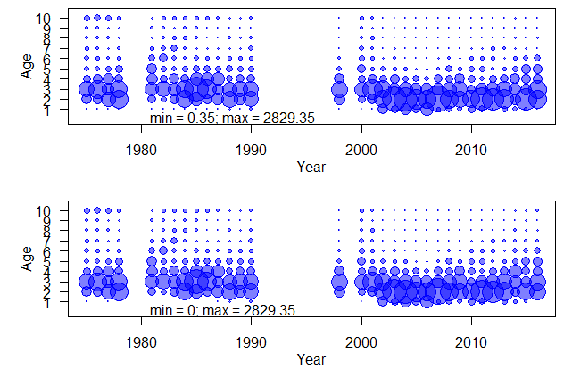Landings at age matrices. Top is the “old” as used in WGNSSK 2017, with only NL in the most recent 3 years. Bottom is the new, where the DK has been included in 2014-2016.

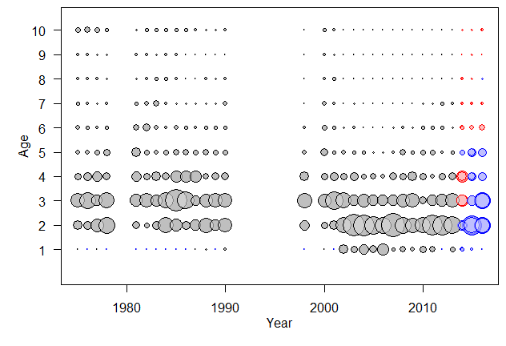

Differences between new and old landings at age matrices: black is equal, blue is less in new (with size of blue ring being relative difference), red is more in new.

* Turbot catch data – age
  + Get data from DK, nothing from DE, UK
  + Also compare age-length key from (Dutch) surveys